SDG India Index 2019 Methodology

**Stages of building the SDG India Index**

The SDG India Index is a product of a chain of three stages.

**Stage 1: SDGs and Targets**

Each of the 17 Sustainable Development Goals are mapped with a set of 169 targets to be achieved by 2030. These were used as the foundation for building the SDG India Index.

**Stage 2: National Indicators List**

The next stage was to identify the national level indicators and map them to the 169 targets of the SDGs for 2030.

NITI Aayog selected a list of 100 indicators that was guided by the MoSPI’s National Indicator Framework.

The National Indicator Framework is the largest monitoring framework in the country, comprising of 306 indicators. It consists of nationally defined indicators corresponding to national priorities and needs. The 100 indicators constructed by NITI Aayog for the SDG India Index 2019 are perfectly aligned with the National Indicator Framework. These indicators were selected by following a set of criteria.

Criteria Adopted in selecting National Indicators

1. Relevance to the UN SDG targets
2. Drawn from National Indicator Framework
3. Availability of data at national level for States and UTs from official statistical systems
4. Consent from respective Ministries
5. Ownership of data by the data source Ministries
6. Sufficient data coverage, such that data for at least 50 percent of the States/UTs is available

Once the list of national indicators was selected, the same was circulated to the relevant Central Ministries and Departments, followed by a round of consultation with them, before being circulated to all States/UTs for their suggestions and comments. Finally 100 indicators were selected for computation of the SDG India Index.

**Data challenges**

The need to measure progress against SDGs rekindled an interest in the quality and availability of data for measuring country’s performance, scheme design and management. Although some progress has been made in strengthening the statistical system, this progress is uneven and India continues to lack in uniform statistical systems. All 28 States and 9 Union Territories use varied data monitoring systems. Domestic requirements for good governance and accountability as a tool for evaluating government performance have increased demand for reliable data. A national framework will enable the development of reliable, high quality data on a range of subjects. Data is currently not available for some of the 306 National Indicators developed by MoSPI. However, to continue the monitoring process initiated last year, NITI Aayog decided to select 100 indicators on which State-wise data is available and consider those indicators for designing the SDG India Index.

**Stage 3: Computing the SDG India Index Scores**

SDG India Index score was computed for India and each of its States and UTs based on the 100 selected indicators. The Index measures India’s progress towards achieving 16 of the 17 Sustainable Development Goals, leaving out SDG 17 from the purview of this Index. SDG 17 is focussed on international partnerships and therefore has been left out as it is less relevant for domestic level policy actions. However, a qualitative assessment on SDG 17 has been included in the SDG India Index 2019.

The SDG India Index was used to rank the States/UTs according to their progress on the 100 indicators.

The steps involved in computing the Index are as follows.

**1. Raw data:**Raw data for each of the 100 indicators was compiled for each State, UT and at the national level.

**2. Missing data:**The purpose of the SDG Index is to guide States/UTs on their SDG priorities. Data for some States/UTs is missing for some indicators. This missing data has been marked as “Null”. In computing the Index, these “null” values have not been given any weightage. In the report, the missing data is flagged so that in future steps can be taken to fill the missing values.

**3. Target setting:**For each indicator, a national target value for 2030 has been set. This target value has been set in one of the three different ways:

* a. A quantifiable national target specified by the Government of India, or
* b. A quantifiable UN SDG target specified under the UN SDGs for 2030, or
* c. The average of the values of the top 3 performing States/UTs

**4. Normalising:** To make data comparable across indicators, State-wise data values of each of the National Indicators was rescaled from its raw form into a score ranging from 0 to 100— with 0 denoting lowest performer and 100 indicating that the target has been achieved. For indicators where increasing value means better performance (E.g. Forest area coverage), score x' was computed as follows:  
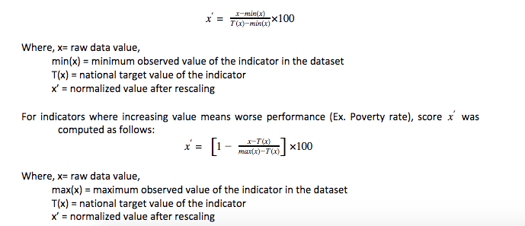

Targets for indicators in SDG 14 were not used to compute normalized score because for most of them the ideal value is not fixed but falls within a range. Raw data in SDG 14 was therefore normalized as follows:

For indicators where increasing value means better performance (E.g. Increase in Water Quality Index),

$$x^{'}=\frac{x-\min\left(x\right)}{\max\left(x\right)-\min\left(x\right)} X 100$$

Where, x = Raw data value

min(x) = minimum observed value of the indicator in the dataset

max(x) = maximum observed value of the indicator in the dataset

x’= normalized score after rescaling

For indicators where increasing value means worse performance (E.g. Increase in usage of nitrogen fertilizers),

$$x^{'}=\left[1-\frac{x-\min\left(x\right)}{\max\left(x\right)-\min\left(x\right)}\right]X 100$$

Where, x = Raw data value

min(x) = minimum observed value of the indicator in the dataset

max(x) = maximum observed value of the indicator in the dataset

x’= normalized score after rescaling

**5. SDG index score:** For each of the Goals under SDGs (except Goal 17), SDG India Index score was computed for each State/UT. This was calculated as the arithmetic mean of the normalised values of all the National Indicators within the Goal. In calculating the average, equal weights were assigned to each indicator and the arithmetic mean was rounded off to the nearest whole number.

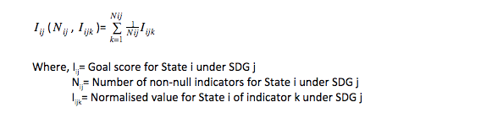

The Goal Score Iij for State I under SDG j was then rounded off to the nearest whole number to give the SDG Index Score. Based on the SDG India Index, States and UTs were classified into 4 categories under each of the SDGs (except Goal 17):

1. Achiever – when SDG India Index score is equal to 100
2. Front Runner – when SDG India Index score is less than 100 but greater than or equal to 65
3. Performer – when SDG India Index score is less than 65 but greater than or equal to 50
4. Aspirant – when SDG India Index score is less than 50

**6. Composite SDG India Index score:**Composite SDG India Index score of each State/UT was finally computed to quantify the overall progress of the States and UTs towards the SDGs. This was calculated as the arithmetic mean of the Goal scores across 16 out of the 17 Goals. This was done by assigning equal weight to every Goal score and the arithmetic mean was rounded off to the nearest whole number.

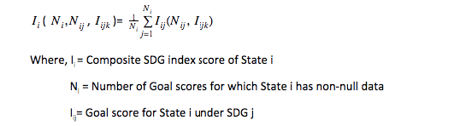

The arithmetic mean of Goal scores were then rounded off to the nearest whole number to give the composite SDG India Index score for each State/UT. The States were again classified into the four categories (as described above): Achiever, Front Runner, Performer and Aspirant.